**Getting more than just a facial with Vasculyse.**

There are just some things that makeup cannot cover up! Guys, if you are reading this, we know you want to look good, too! Have you looked in the mirror and cringed at the interesting things that seem to visit us from time to time? Not very many of us are blessed with perfect flawless skin. Since our face is so visible, having skin problems will often affect the quality of our life and our self confidence.

A young man in his early twenties had his whole world turn around with the Vasculyse treatments. Coming in for treatments initially was a young man with no self confidence, shy and in despair. His head down and wearing a hoodie was just his way. After, several treatments and many skin tags later, he walked with his head up and no hoodie was to be seen. From miserable to joyful is a rewarding and inspiring transformation to witness. Our face can be considered as the window to our world. This young man’s world changed.

A lot, of skin conditions can be treated quickly and efficiently…so goodbye to stressing about your skin and hello to quick solutions, happy clients and wonderful technologies!

With Vasculyse available these treatments can be done quickly, efficiently and virtually painlessly.

Broken capillaries, ruby points, milia, cholesterol deposits around eyes, and skin tags on the face, neck or body can be treated quite easily. One of the best technologies available today is the Vasculyse Machine. It is a computerized system that is non invasive. It uses mild currents to the area of concern. This treatment is called Capillary Coalysis or Coagulation. The technician works around the area with the tip. The tips used with the device must be used only once per client in order to maintain strict sanitation procedures. You might feel a slight pricking sensation during the treatment but it is over so fast that it’s hardly a concern. Because we are cutting off blood flow to the distended area skin tags and broken capillaries will not return. You may get others in other areas if you are prone to these conditions. Some of these conditions may also be genetic but using good skin care and sunscreen can be helpful with broken capillaries and milia. The technician using the system must be trained and knowledgeable with a good understanding of the skin. A good consultation is always paramount with any skin treatment. We need to know what bothers you because we all have different needs.

The pictures below are helpful in identifying what you may have. It shows the results immediately after treatment except for the skin tags which sometimes may take several days to fall off. Most cases only require one treatment but in some cases you may require multiple treatments to treat some conditions.

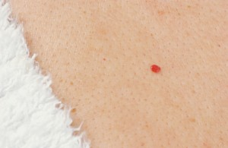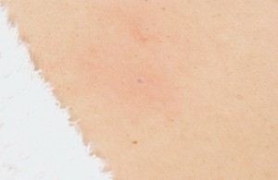

Ruby Point (before) Ruby Point (after)

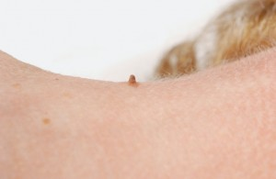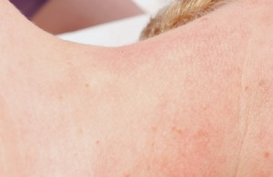

Skin Tag (before) Skin Tag (after)

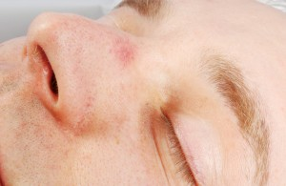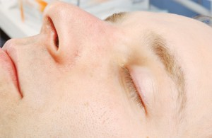

Spider Angioma (before) Spider Angioma (after)

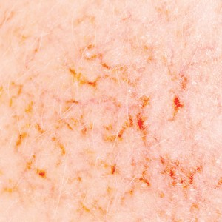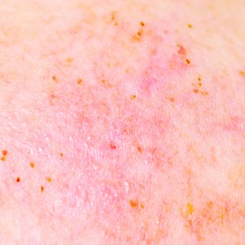

Broken Capillaries (before) Broken Capillaries (after )